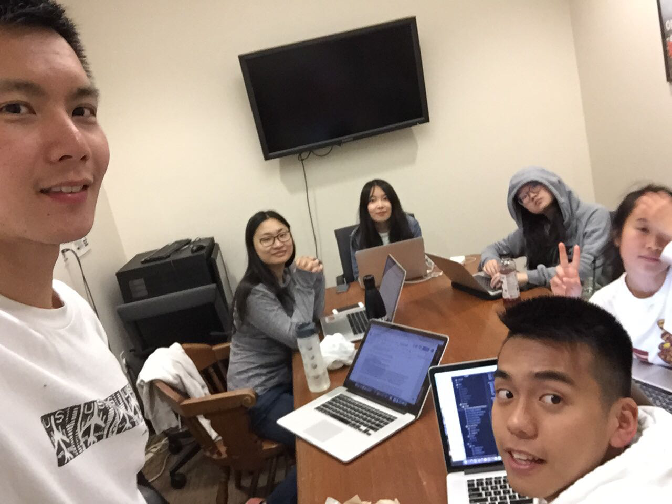

Allocated meeting time: April 26th, 8:00pm-9:00pm

Actual meeting time: April 26th, 8:30pm-9:30pm

Product owner: Professor Halfond, TAs, CPs

Scrum master: Gong Chen

Team members: Lingyi Li, Joann Lin, Peixuan Liu, Ryan To, Tuling Zhao

Scrum summary:

We were finalizing our sprint 3 process report. We were also communicating the architecture and organization of all our code so Gong can demonstrate it to the grader.

1. What have you accomplished since the last meeting?
2. Are there any obstacles in the way of meeting your goal?
3. What will you accomplish before the next meeting?

Gong Chen:

1. Working on the document
2. None
3. Finishing the document

Lingyi Li:

1. I finished the task charts and burndown charts for this sprint.
2. None.
3. I will write the sustainable pace section in the document

Joann Lin:

1. Worked on documentation
2. None
3. Will help finalize document

Peixuan Liu:

1. Refactored AWSClient so that we have a higher white-box coverage; added more test cases to ResizeCollageTest and SaveCollageServletTest
2. None
3. None

Ryan To:

1. I will install cucumber on Gong’s machine so that it is ready for our demo day
2. None
3. Will finalize documentation

Tuling Zhao:

1. Worked on documentation
2. None
3. Will work on documentation